**E-Project Developer Guide**

**Online Insurance**

**Group Members:-**

* Corunes Bhatti

ID: Student1399540

* Muhammad Shabbir

ID: Student1397587

* Usman Ali

ID: Student1399280

* Asad Ullah

ID: Student1396409

* Hafiz Muhammad Sameed

ID: Student1398528

**Faculty Members:-**

**Teacher: Miss Neha Shah**

**Coordinator: Miss Fiza Arif**

**Table of Contents:-**

E- project……………………………………………………...1

Group intro…………………………………………………...2

Table of content………………………………………………3

Acknowledgment…………………………………………….4

Problem Statement...…………………………………………5

Proposed Solution...……………………….…………………6

Hardware/ Software Requirements……..…………………8

Screen shots…………………………………………………...9

Conclusion…………………………………………………...20

**ACKNOWLEDGEMENT**

We are deeply grateful to the **Almighty Allah**, for His blessings and guidance, which have enabled us to successfully complete our **E Project of online insurance**. We have made every effort to consider all relevant and important topics in the development of this project, aiming to make it comprehensive and valuable.

We would like to extend our heartfelt appreciation and thanks to all the individuals who have played a crucial role in our journey towards project completion. Without the support of these individuals, our achievement would not have been possible.

We would like to express our sincere gratitude to our dedicated faculty member, **Miss Neha Shah**, and our coordinator, **Miss Fiza Arif**. Their unwavering support, guidance, continuous encouragement, and supervision throughout the course of this project have been invaluable. We consider ourselves fortunate to have had the opportunity to work under the tutelage of such a supportive and cooperative teacher and coordinator.

**Problem Statement**

**Problem Overview:**

Insurance is a contract for payment of a sum of money to the person assured on the happening of the event insured against. Usually the contract provides for the payment of an amount on the date of maturity or at specified dates at periodic intervals or at unfortunate death, if it occurs earlier. Among other things, the contract also provides for the payment of premium periodically to the Corporation by the assured. Insurance is universally acknowledged to be an institution which eliminates `risk', substituting certainty for uncertainty and comes to the timely aid of the family in the unfortunate event of death of the breadwinner.

# Project Requirements:

This software provides four types of Insurance services, which includes Life Insurance, medical Insurance, Motor Insurance. Home Insurance,  
Presently this project follows Internet mode i.e. the details can be viewed and updated by the officials of the company.

Online Insurance Service has the following features:-

1). A User can view the details of various policies and schemes offered by the Insurance Company.   
2).**New Users** can register with the site so that he can get information online.  
3).An existing policyholder can view his policy details and calculate the premium.  
4).The web site provides information about the new strategies and subsidiary  
schemes of the company.   
5).Provides loan facility for policyholders and online payments.Calculation of the premium is to be done Term plan taken by the person.

# Insurance includes

**Life Insurance**: Life insurance is a plan which provides protection to the insured and his family with financial coverage in case of any mishaps. To avail the benefits of life insurance policy, the policy holder has to pay a monthly premium to the insurer for a certain period of time.

**Medical Insurance:** Under this type of health care cover, medical expenses are covered. When an insured person needs medical treatment due to illness or accident, the insurance agent provides coverage for his expenses such as doctor fees, hospital fees, medicine cost and other related bills.

**Motor insurance:** Under this type of plan which provides protection against the auto-mobile the user owns.

**Home Insurance:** The most popular among the **6 types of insurance** is the home insurance that provides compensation for any mishaps that occurs on your home. Coverage is provided according to the policy and premium paid by the homeowner. There are various types of home insurance plans that you can choose from to suit your needs.

**Proposed Solution:**

SRS Electrical Appliances has developed a web application to streamline the testing and quality control record management process.

**Key Features:**

**Database:** A comprehensive database for product details, testing results, and remarks.

**ID Generation:** Automatic 10-digit product IDs and 12-digit testing IDs.

**Modular Design:** Organized by product and testing types.

**Advanced Search:** Quick data retrieval.

**Remarks:** Detailed notes on testing criteria and outcomes.

**Status Tracking:** Monitor testing status.

**User Input:** Record testers' names.

**Benefits:**

**Improved Data Management:** Efficient storage and retrieval, reducing errors.

**Enhanced Accessibility:** Quick access to records for faster decisions.

**Cost Reduction:** Fewer re-manufacturing instances.

**Faster Market Approval:** Expedited CPRI approvals.

**Functional Requirements:**

**Data Capture:** Record testing details.

**Record Maintenance:** Detailed remarks.

**Advanced Search:** Ease data retrieval.

**Unique ID Generation:** Automatic IDs.

**Modular Organization:** Organize data.

**Status Tracking:** Monitor testing status.

**User Input:** Record testers' names.

The website offers a comprehensive solution to SRS Electrical Appliances' testing and record-keeping challenges, improving efficiency and accuracy.

**Hardware/ Software Requirements**

**Hardware**

* A minimum computer system that will help you access all the tools in the courses is a Pentium 166 or better
* 128 Megabytes of RAM or better

**Operating System**

* LINUX / Windows 2000 Server (or higher if possible)

**Software**

* Visual Studio 8.0 .Net / ASP
* IIS server
* .Net Framework
* Java Virtual Machine/ J2EE server
* Notepad/Java editor
* j2sdk1.4.1_02 (or later).
* EJB Dev Kit
* Java enabled web server
* JSP / Servlets Dev. Kit

**Screenshots**

***Add Policy View:***

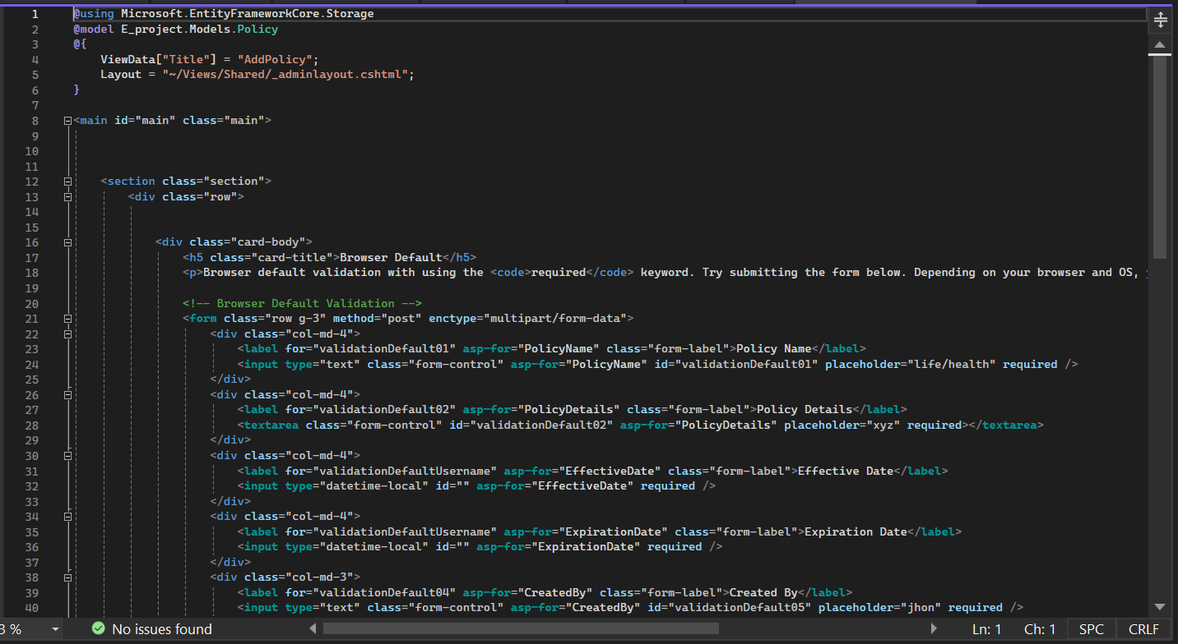

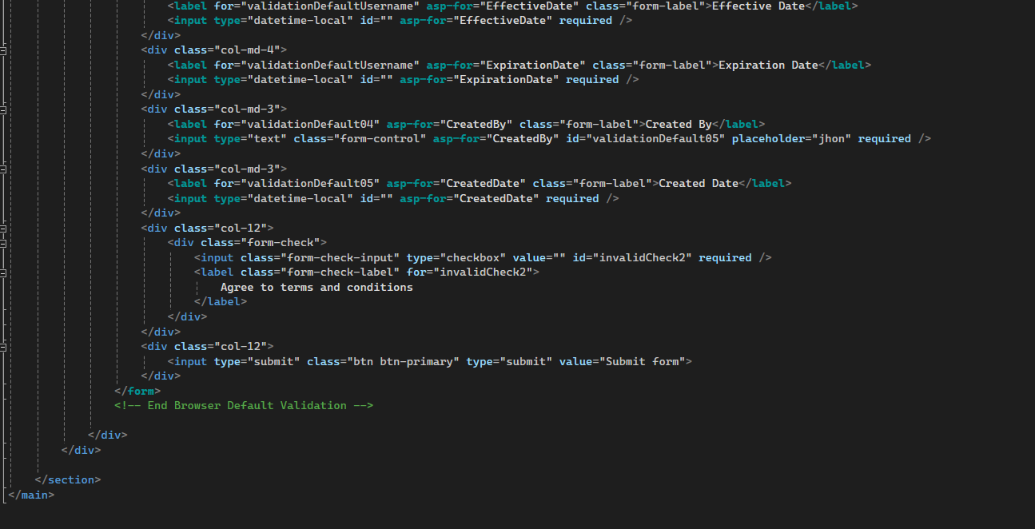

***Policy View:***

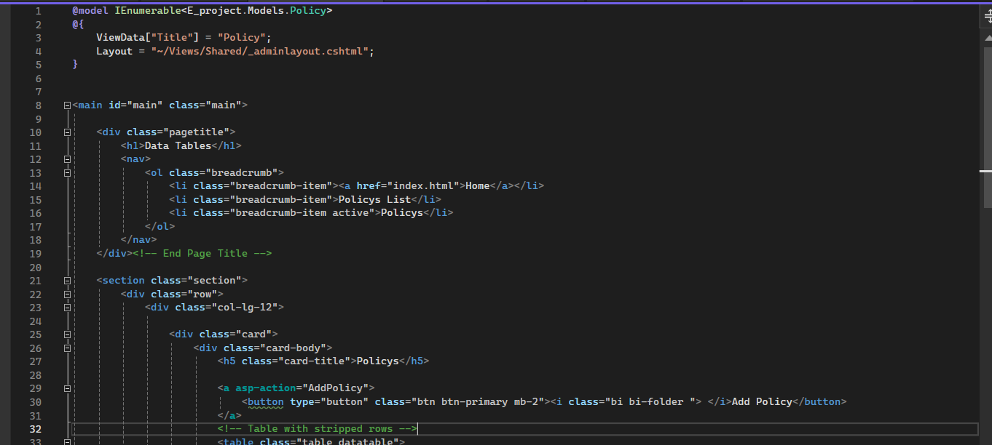

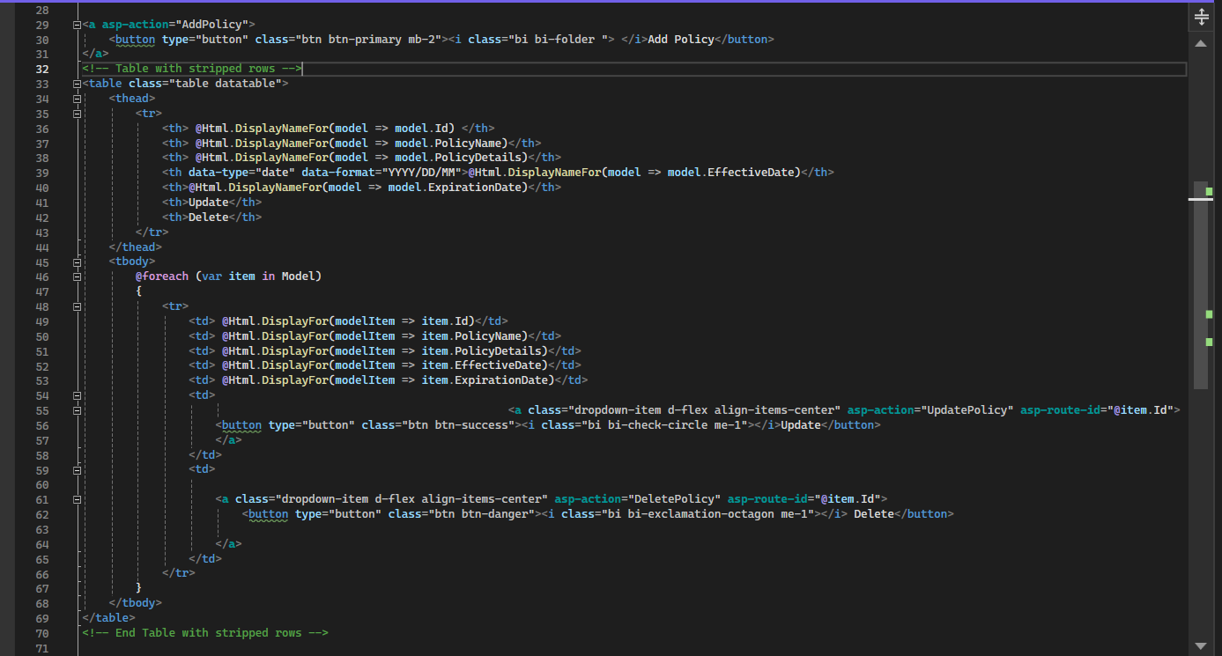

***Delete Policy View:***

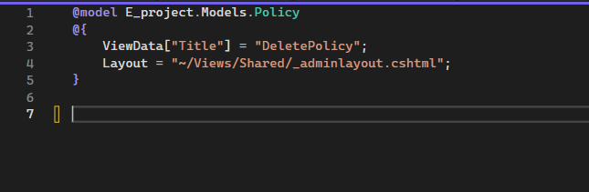

***Policy Add Or Show Controller:***

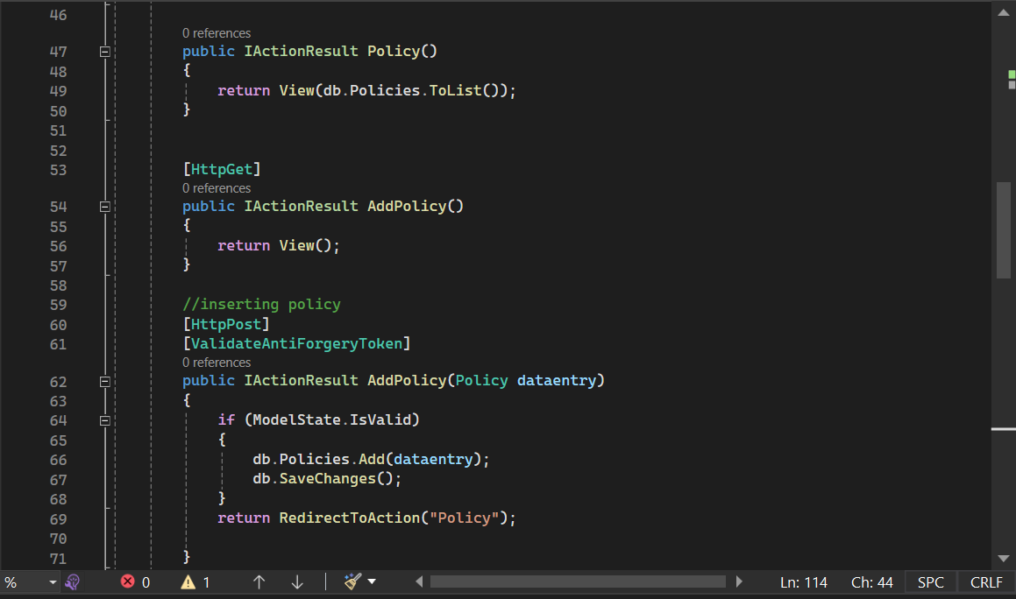

***Policy Delete Controller:***

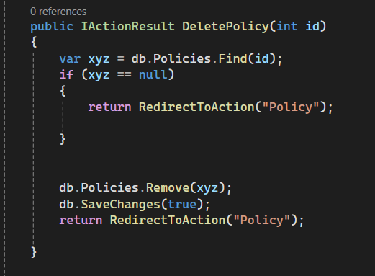

***Policy Model:***

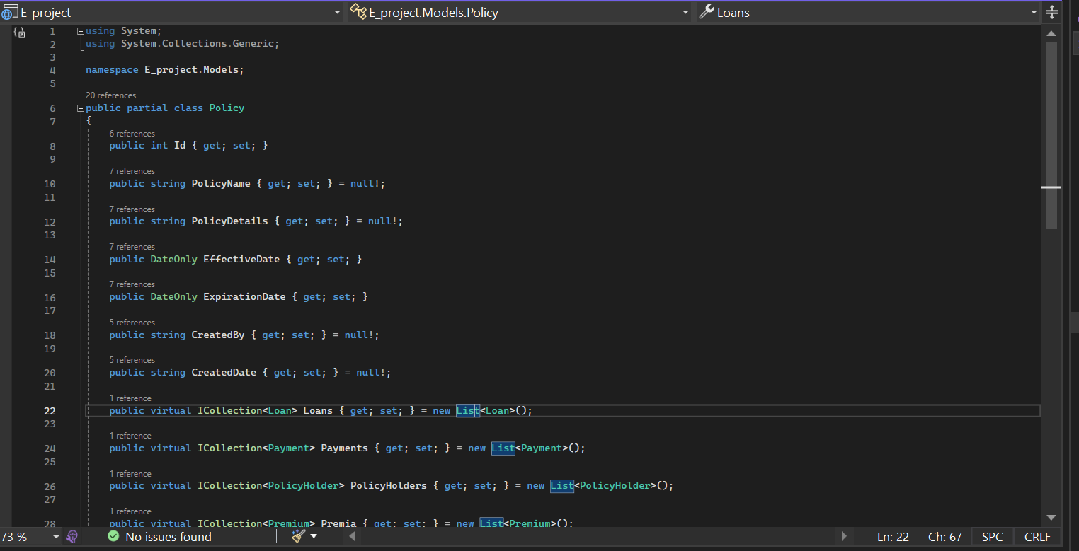

***Policy Update Controller:***

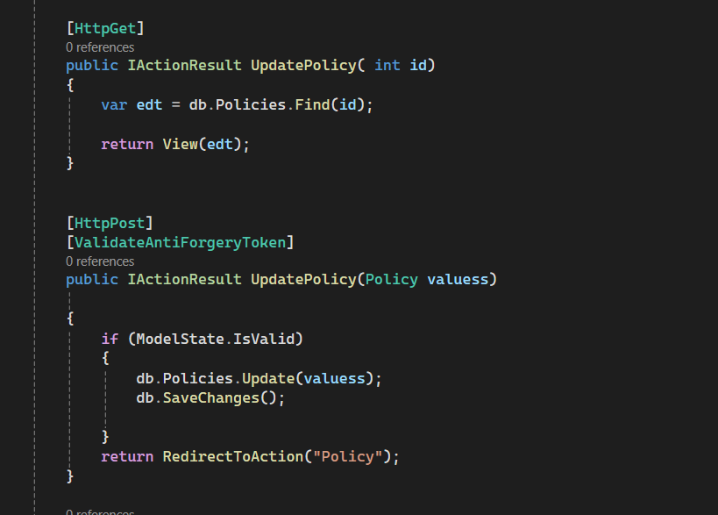

***User List Show Controller:***

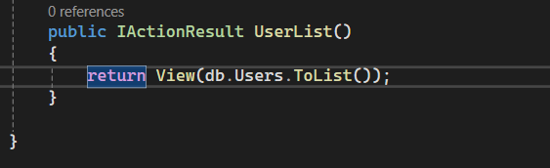  
  
***User List View:***

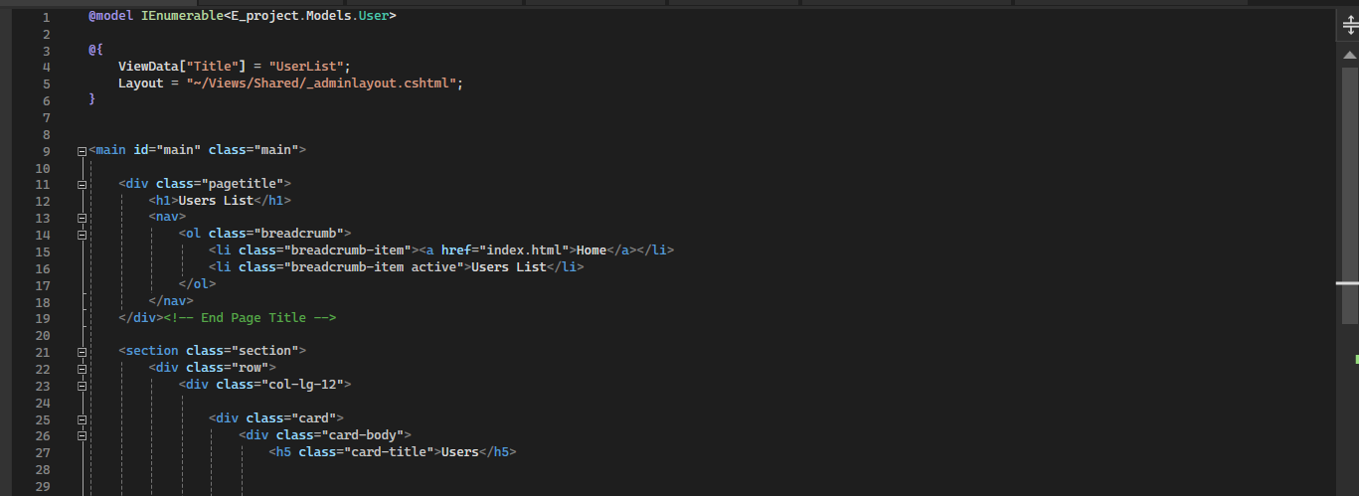

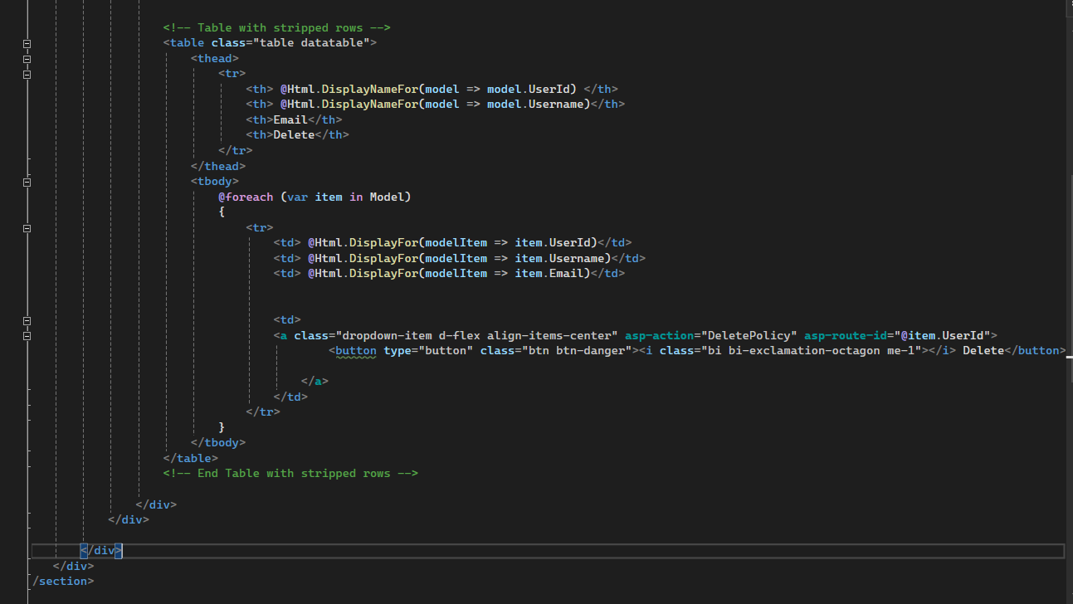

***User Model:***

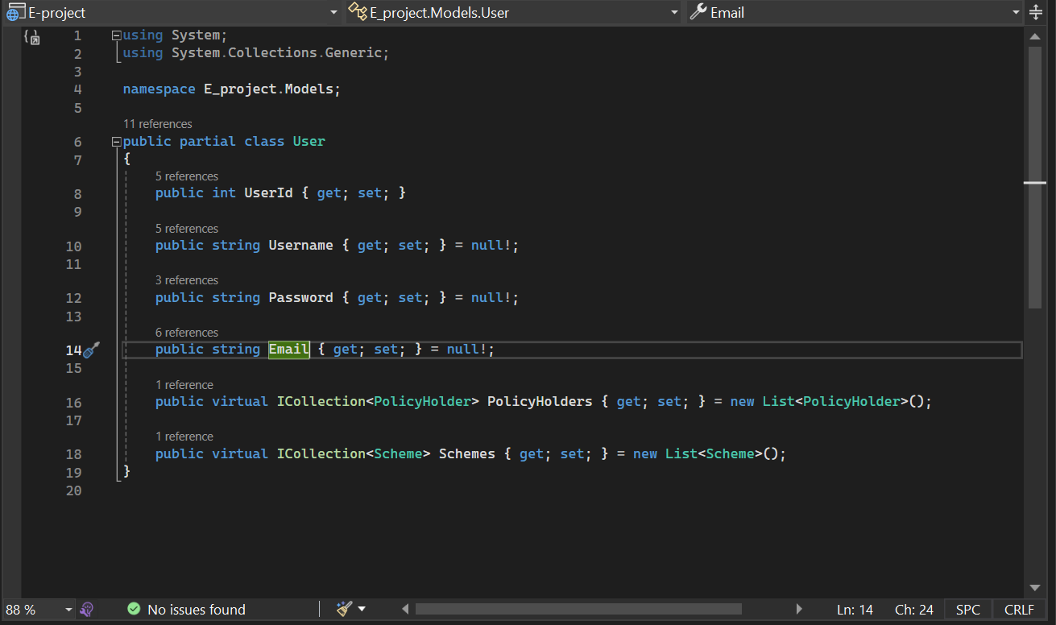

**Conclusion:**

In wrapping up, completing our online insurance project is a big deal. We wanted to make sure people could easily get insurance online, covering things like life, health, car, and home insurance.

Big thanks to our teacher, **Miss Neha Shah**, and coordinator, **Miss Fiza Arif**, for their support.

Our solution has cool features like a database, automatic ID creation, and easy searching. It's designed to make insurance stuff simpler and quicker for everyone involved.

We made sure our project works well with standard computers and software, so it's easy for people to use.

Overall, we're proud of what we've done. This project should make getting insurance online easier for people, and that's pretty awesome. Thanks to everyone who helped make it happen!

**Thank You:-**